The meeting was called to order by Debra Greenway at 7:02pm.

Introductions of Attending: Debra Greenway, Lisa Paradis, Irma Nevarez, Jennifer Mullin, Paula Rivera, Tarri Swanson, Ken McKim, Adrienne Simon-Carlson, Karen Yoon, Jenny Sindel, Ashley Burgdoff, Ian Pund, Heather Taylor, Misaki Curtis, Erin O’Donnell, Gina Murphy,

President’s Report – Deb Greenway
- Welcomed everyone. No need to reintroduce as everyone in attendance are the same from that last meeting.

Teacher’s Report (Ken McKim):
- Solicited info from teachers but didn’t receive anything. Basically things are going well. My impression are that teachers are a bit tired as they have dealt with progress reports which ended the previous Friday. Had until this last Friday to change or amends grades. A big thing as you are trying to identify who needs help and giving kids a chance to make up work. They are generally tired but the assessments answer the questions of how we best meet the needs of kids and how to address the deferential challenges.
- Heather Taylor - thank you to the PTO for going to the School Board Meeting and advocating for the Harper Fields. Thankful that we are finally getting heard and felt validated. Hopefully there will be a change on the horizon. Appreciate PTO and thankful.
- Deb Greenway – Thank you to all that came and people who emailed.

Principal’s Report – Jennifer Mullin

  - We are supposed to receive some kind of communication this week from the district and will send out to the community.
  - Trying to get parent communication out weekly but wasn’t able to get one out this week. Goal is to get out a weekly communication from the principal with the most important points of the week. Aiming to get it out on Fridays. Will continue to receive daily communications
  - School governance is on October 26th 5 pm – 7 pm via zoom. It’s a time where families can come and listen to major things that are happening in the district and learn more of how to become part of PTO, site council, and climate committee.
  - New athletic COVID testing policy for 7th and 8th graders. Will need to be tested once a week and provide a negative COVID test to coaches on Monday. Already a practice at the high school.
  - Things have seemed to calm down. Kids seem to have gotten into the rhythm of things.
  - Deb – encouraged that Matt Best reached out the next day about the fields.

Counselor’s Report (Adrianne Simon-Carlson)
- For the month of October we are starting off with classroom visits with children on our caseloads. Introduce ourselves and discuss our roles. Usually do this in September but everything is delayed by one month. You may see out of office messages because we will be in the classrooms for 5 -6 periods a day. We are on campus just in the classrooms. We have a lot of new students from out of district, so just trying to get to know our students. Making sure that they feel safe, happy, and healthy at school. Making sure that they have the resources they need to be successful.
- Lots of check in’s and lots of follow ups from crises that have happened. In the month of September it’s a lot about schedule changing, attendance, and checking in on anxiety. October is gearing up on meeting with children that may need more support especially now that we have progress reports. Encourage families to reach out to the counselors if they need assistance. Contact info is on the website.
- Trying to do a parent night once each season. If there are any topics that people are interested in or interested in learning more about let us know.
- Activities- Leadership group up and running. First spirt week from the 18th – 22nd. Impressed with the creativity that the students came up.
- Introduced Husky Paw Points this month. System that we use to check engagement. We use an app called 5 star students, with the app we are able to check in students at events, give them points for positive behavior, positive referrals. Students can take the points to our student store during spirit week and turn them in for prize rewards. Gives us a chance to look at the data and see who is engaged and look at what we may need to bring to those students who are not as engaged based off of what we offer currently.
- Introducing spirit wear. Working with a vendor for t-shirts, long t-shirt, sweatshirts, and sweats. Prices range from $12 - $25. Fair pricing so everyone can afford it. Order extra in case families that want it but can’t afford it, we can offer a discounted price.
  - Parent reports that they appreciate what they are doing around engagement. Handing out candy etc.

VP of membership Update (Paula Rivera)
- 57 Members this year. Last year we had 4. Not sure what we had prior to the pandemic. Half the families wanted 2 memberships. It’s really hard to reconcile the money. Maybe change the form for next year. Possible that we may have had 34 members prior to COVID.

Treasurer’s report – (Ian Pund)
- Nothing crazy going on. Working on our taxes from last year.
- Continue to get Nugget deposits

VP Fundraising – (Tarri Swanson)
- Scheduled a Chipotle Night out November 2nd Flyers are in English and Spanish. People can order online. Flyers have a code which give Harper credit for their order (Cancelled)
- Reminder went out to parents to sign up for Amazon Smile and Nugget Script
- Main focus for tonight is to present the grant applications. Part of the process is to accept the applications and then review them with the principal, president and any interested board members. Then present them at the general membership meeting to vote on approving them or not approving them. Received 24 grant applications this Fall. We have a $5000 budget and we received almost $10,000 in grants. Double the amount that we have in our budget. The principal has some money in her budget that she can allot for some of the grants. She will look for alternate funding sources or fund them. 19 will be presented tonight.

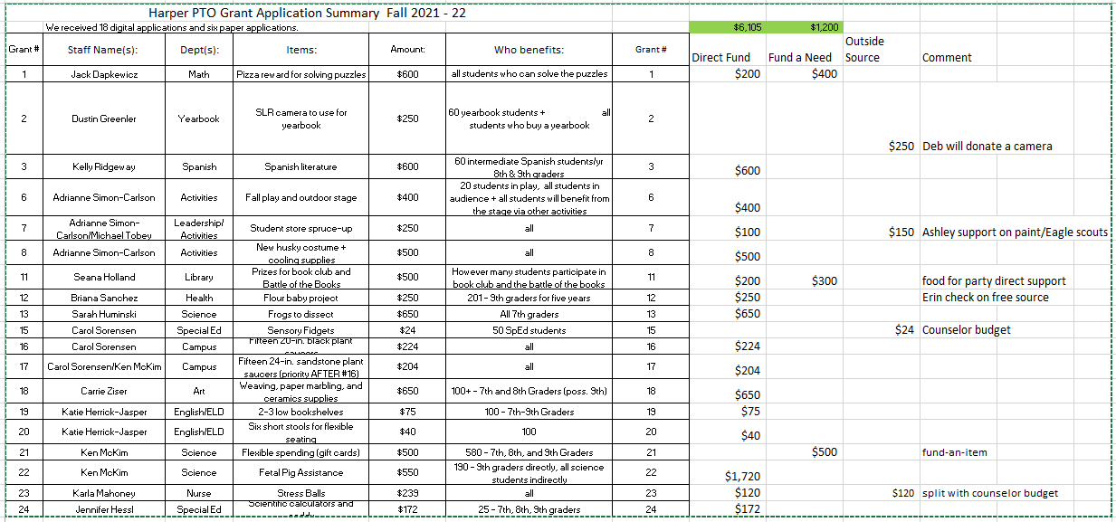

Approval of minutes (Deb Greenway) September Minutes stand approved as sent. Ken McKim makes a motion to approve minutes. Ian Pund seconded it. Motion passes.

Meeting adjourned at 8:57pm

